Quality Plan

Student Activities Management System

1. Introduction
This document, together with other referenced documents, defines the responsibilities and procedures to be adopted to ensure that the data and information produced as part of Project [project No] are reliable, fit for purpose and consistent with documented objectives and deliverables. It summarises the system of internal management that governs the decisions and instructions concerning project quality assurance.

2. Project Contractual Information

Project: | Student Activities Management System
Project Number: | 105
Programme Co-ordinator: | N / A
Principal Investigators(s): | Ms. Roselle Wednesday Gardon  - Project Team consultant for Graphical User Interface  Mr. Justin David Pineda  - Project Team Consultant for System Security issues and implementations  Mr. Jacob A. Catayoc  - Project Team Adviser for reviewing overall changes to system development

3. Scope of Work and Quality Objectives

Scope of work: | Include a reference to the project proposal
QA Requirement:

4. Project Organisation

Project Manager(s): | Ferrer, John Kenneth H.
Task Manager(s): | John Kenneth Ferrer – Project Manager  Chamber Jose – Project Developer
Quality Assurance: | Chamber Jose – Project Developer  Rempson Dulitin – Project Developer
Other Team Members: | Jose, Chamber F. (Project Developer)  Dulitin, Rempson P.
Subcontractors: | N / A
User Community: | APC Student Activities Office Head  Organizational Heads
Technical Reviews: | Jacob Catayoc – Project Adviser  Roselle Gardon – Project consultant  Justine Pineda – Project consultant

5. Project Duration and Scheduling

Start Date: | April 2016
Completion Date: | March 2017
Scheduling of Activities:

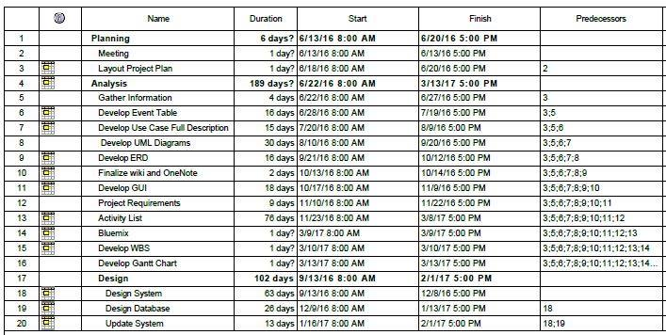
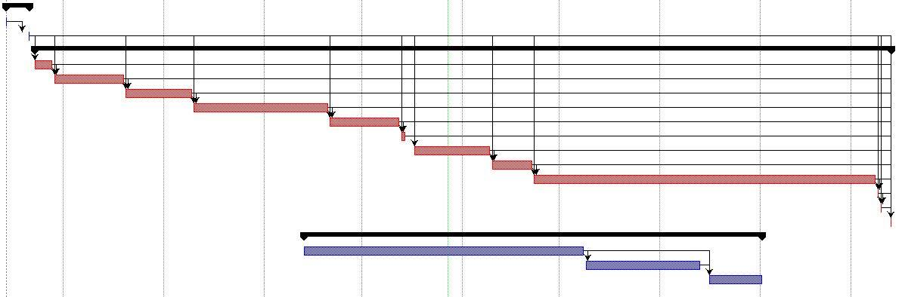

6. Deliverables
Deliverables specified for the project include:

- An acceptable quality plan
- An acceptable Change Management Plan
- An acceptable Software Requirement Specification
- An acceptable Scope of Work
- An acceptable Project Vison and Scope
- Progress Reports
- User manuals
- Final paper

7. Review of Quality Plan
The developers of the Student Activities Management System will have atleatst one or two meetings with the client to able to review the quality plan of the system.1

8. Document and Record Control
Project documents, including Progress reports, Change Management plans, statement of work and other documents are under control by the project team and are open for consultation by all members to ensure that the project is still following the set requirements and specifications. Moreover, these project documents are stored in the project’s cloud repository, GitHub while image files related to the project including diagrams and other system diagram designs are stored in image hosting website, photo bucket. Whereas the overall contents of the whole project documentation are stored within Projects2 Wiki page

9. Documented Procedures
Methodology for Implementing Document Management Systems to Support ISO 9001:2008 Quality Management Systems
ISO 30301. Information and documentation -- Management systems for records.
ISO 9000. Quality management.
ISO 9001:2008. Quality management systems.

10. Additional Information
Unless included in associated technical procedures, any other information that has direct relevance to the quality of the product or service being provided should be included in the Quality Plan. This could include [add or delete as necessary]:
- special requirements for the procurement of services or goods, including subcontractors;
- additional procedures and controls for the review and verification of deliverables or other documents;
- special requirements for the identification and traceability of products, including, where applicable, the traceability of staff performing specific duties;
- special criteria for identifying the status of inspection and test products;
- minimum qualifications, training or experience required of staff to undertake certain activities, or any specialist staff training;
- process control requirements, including monitoring of activities;
- special procedures for the handling, storage, packaging, preservation and delivery of product;
- requirement for servicing of a product for which ongoing maintenance is required;
- specialist statistical techniques required.

Prepared by: Date: November 24, 2016
Jose, Chamber F.
Ferrer, John Kenneth H.
Dulitin, Rempson P.

Checked by: Date:
Mr. Manuel Sebastian S. Sanchez

Approved by: Date:
Mr. Manuel Sebastian S. Sanchez

